1.Digital Thermometer

Introduction
A digital thermometer is an electronic device used to measure temperature accurately. It uses a temperature sensor and electronic circuits to display the temperature in numeric form on a digital screen. Digital thermometers are commonly used in homes, hospitals, laboratories, and industries. 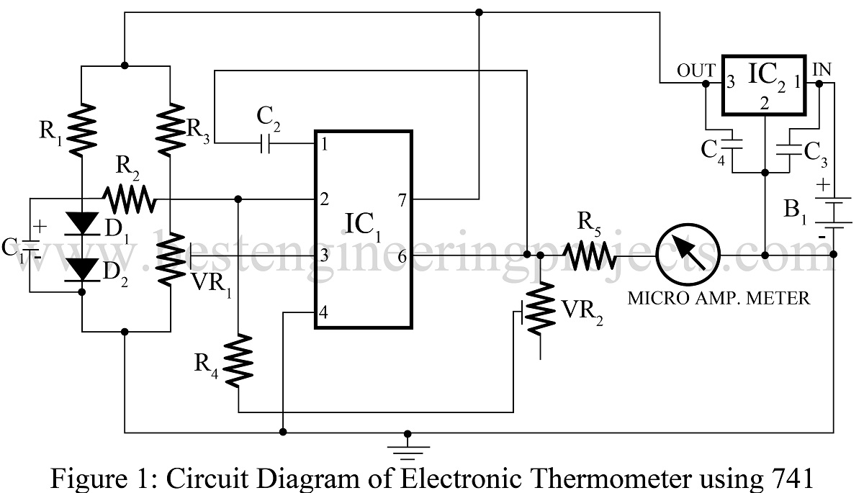

Diagram of a Digital Thermometer (Labeled)
┌───────────────────────────────┐
│ Plastic Body │
│ │
│ ┌───────────────────────┐ │
│ │ LCD Display │ │
│ │ (Temperature °C/°F) │ │
│ └───────────────────────┘ │
│ │
│ ON / OFF Button │
│ │
│ ┌───────────────────────┐ │
│ │ Microcontroller / │ │
│ │ Signal Processor │ │
│ └───────────────────────┘ │
│ │
│ Battery (Cell) │
│ │
│───────────────────────────────│
│ Metal Sensor Tip │
│ (Thermistor / IC Sensor) │
└───────────────────────────────┘

Main Parts and Their Functions

1. Temperature Sensor (Thermistor / IC Sensor)
- Located at the metal tip of the thermometer.
- Detects temperature changes.
- Converts temperature into an electrical signal.

2. Metal Tip
- Comes in contact with the object or body.
- Protects the temperature sensor.
- Helps in quick and accurate heat transfer.

3. Microcontroller (Processing Unit)
- Acts as the brain of the thermometer.
- Converts the sensor’s electrical signal into a temperature value.
- Controls the display and other functions.

4. LCD Display
- Shows the measured temperature in °C or °F.
- Easy to read and gives quick results.

5. ON/OFF Button
- Used to switch the thermometer on or off.
- Helps save battery power.

6. Battery
- Provides power to the thermometer.
- Usually a small button cell.

7. Plastic Body (Casing)
- Protects internal electronic components.
- Makes the thermometer easy and safe to handle.

Working Principle (Simple)
- The sensor senses the temperature.
- The sensor converts temperature into an electrical signal.
- The microcontroller processes the signal.
- The temperature value is shown on the LCD display.

Advantages
- High accuracy
- Easy to use
- Quick results
- Safe and portable
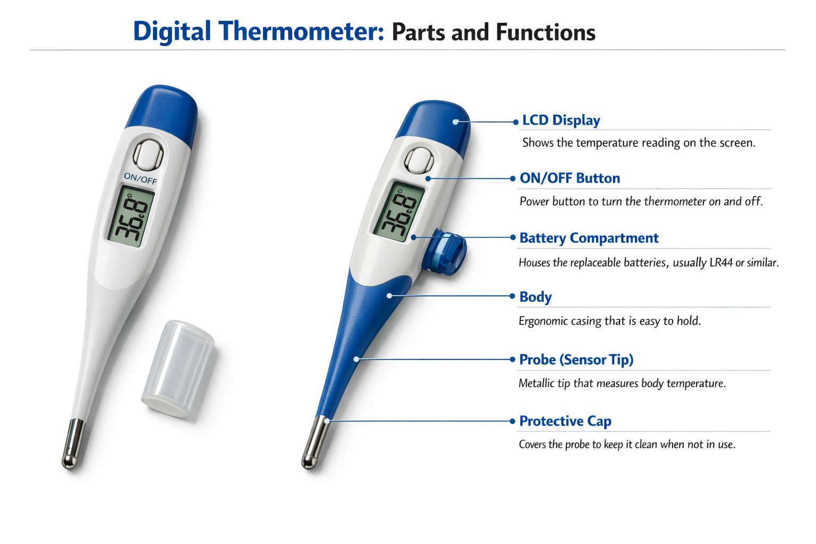

Applications
- Measuring human body temperature
- Laboratory experiments
- Industrial temperature monitoring
- 